S475/1
SUBSIDIARY
MATHEMATICS
JULY/ AUGUST 2019
2²/₃ hours

BUGANDA EXAMINATION COUNCIL MOCKS – 2019
Uganda Advanced Certificate of Education
SUBSIDIARY MATHEMATICS
Paper 1
2 hours 40 minutes

INSTRUCTIONS TO CANDIDATES:
- Answer ALL the eight questions in section A and only four questions in section B.
- Any additional question(s) answered will not be marked.
- Each question in section A carries 5 marks while each question in section B carries 15 marks
- Your work must be tidy and begin each question on a fresh sheet of paper
- Graph paper is provided
- Silent, non-programmable scientific calculators and mathematical tables with a list of formulae may be used
- Where necessary, take g = 9.8 ms⁻²

SECTION A: (40 MARKS)
Answer ALL the questions in this section
- Prove that 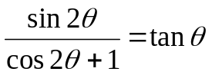
Hence find θ in the range 0 < θ < 360 if 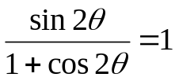 (5 marks)
- The tenth term of an arithmetic progression is 69 and the sum of the first 30 terms is four times the sum of the first ten terms. Find the first term and the common difference of the a.p. (5 marks)

- Solve for x given that 3^{2x+1} + 2b(3^{x}) = 9 by using substitution y=3^{x}. (5 marks)
- Given that 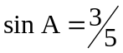 and 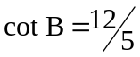where A and B are all a cute, find the values of;
- Cos (A+B)
- tan(A+B) (5 marks)
- Use dot product rule to find angle between vectors 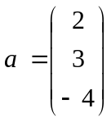 and 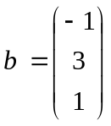. (5 marks)
- Given that y=3x⁴ – 12x² + 5
Find;
- 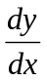at x = 1
- the maximum and minimum values of y. (5 marks)
- Evaluate;
- 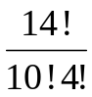 (3 marks)
- 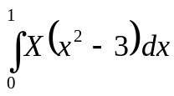 (2 marks)

- The two particles of mass m and 3 kg are, connected by a light inextensible string passing over a smooth fixed pulley as shown in the figure.
m
3

The system is set free and 3 kg mass accelerated upwards at 2 m/s².
Determine;

- Tension in the string
- Mass m. (5 marks)
SECTION B: (60 MARKS)
- A random variable x has a probability density function given by;
Cx (2 – x ), 0 < x < 2
f(x) =
0 , elsewhere
Find;
- Constant C
- Expectation of x.
- P(0.5 < x < 1.5) (15 marks)
- The table below shows marks scored by a group of students as marked out of 50.
Marks | Frequency
1 – 10 | 15
11 – 20 | 20
21 – 30 | 32
31 – 40 | 26
41 – 50 | 7

Determine;
- Mean mark.
- Make a histogram and use it to find mode mark.
- Use suitable formula to find median.
- What is the probability that a student chosen at random scored above 30 marks.
(15 marks)

- (a) Events A and B are such that P(A) =, P(B) = and P(A/B) = 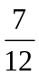
Find;
- 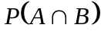
- 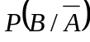
b) A factory sells paint in packets. The weights of packets are normally distributed with mean of 50 kg and standard deviation of 3 kg.
Find the probability that weight of any bag selected at random;
- is less than 54 kg
- is between 48 kg and 57 kg (15 marks)

- (a) Solve for x and y in simultaneous equations using matrix method.
2x – 3y = 11
x+4y = 22
b) Put 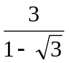in the form a+b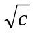
c) Solve for x if 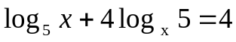 (15 marks)
- The table below shows marks scored by 8 students in tests of Maths and physics in a village school.

Participants | A | B | C | D | E | F | G | H
Maths (x) | 72 | 60 | 56 | 76 | 68 | 52 | 80 | 64
Physics (y) | 56 | 44 | 60 | 74 | 66 | 38 | 68 | 52

- Make a scatter diagram for the above.
- On the scatter diagram draw the line of best fit and use it to estimate the score of physics for one who got 70 in maths.
- Compute spearman’s rank correlation coefficient. (15 marks)

- (a) Forces of 8N and 5N act on a particle at angle of 60º between them.
Find the magnitude of the resultant.
b) A uniform rod AB of length 14 m and mass 20 kg rests on two supports one at end A and the other at C, 4 m from B.
Find the reactions at A and C, G is the centre of gravity.
A
B
C
4
G

- A particle is projected vertically upwards with initial velocity of 49 m/s. Find its height reached to the nearest metre. (15 marks)

END

